**Cashback Coupon for WooCommerce**

This is the help documentation for the Cashback Coupon for WooCommerce plugin. Before installing the plugin please go through this help document which will make you easier for you.

If you've tried this manual and it hasn't solved your issue, please feel free to contact us at support@wpcodelibrary.com

**Contents**

1. Introduction

2. Requirements

3. Installation Guide

4. How to setup and use plugin?

* **Introduction**

- Cashback Coupon for WooCommerce plugin allows you to send automated generated coupon to your customers once the order is completed.

1. Enable send cashback coupon on order completion.
2. Set fix cashback amount for coupon.
3. Set limit usage for coupon before it void.
4. Set individual use only if the coupon cannot be used in conjunction with other coupons.
5. Set apply before tax coupon.
6. Set delete coupon after usage.

* **Requirements**

1. WordPress 4.0+
2. WooCommerce 3.0 +
3. jQuery(comes with WordPress3.8+)
4. jQueryUI (comes with WordPress3.8+)
5. Latest browsers like Firefoxor, Chrome.

* **Installation Guide**

Installing **Cashback Coupon for WooCommerce plugin** is very simple and easy.

Please follow below steps for installation.

* **Upload via FTP:**

Unzip the .zip file that you have downloaded to your computer and upload to your server via FTP to the plugin directory of your wordpress installation (wp-content > plugins).

* **Upload via WordPress Admin:**

Go to your wordpress admin panel, and then click to plugins. Click on "AddNew" and then upload the zip file of the plugin with the Upload Plugin button.

* **Activate the Plugin**

Once you uploaded your plugin successfully you will find **Cashback Coupon for WooCommerce** in your plugin list. Click on activate That's It!

**How to setup and use plugin?**

* + **Setting up a plugin is very easy and user friendly. Once you activate the plugin you will find Cashback Coupon Settings under the WooCommerce menu. There you will have all necessary plugin settings available which are required.**

Please see below screenshots for more understanding.

1. Screenshot ( Settings Page )

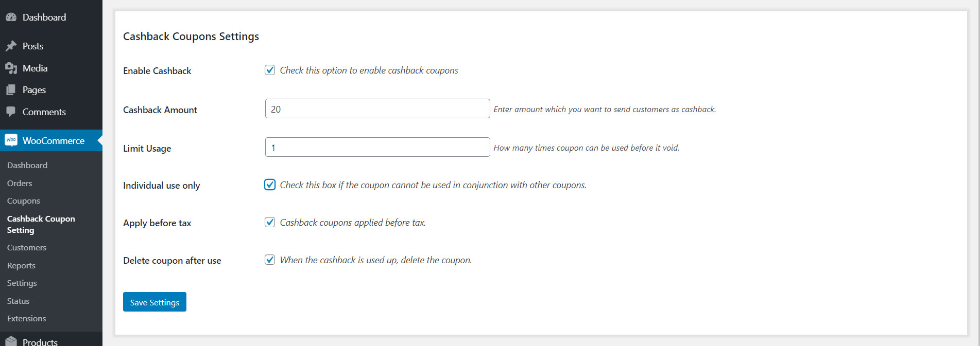

2. Screenshot ( Coupons Tab )

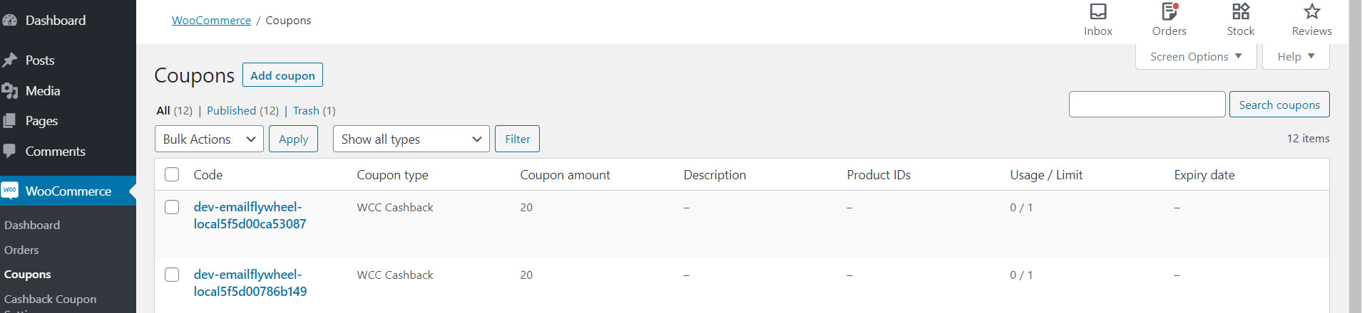

3. Plugin in Action

( Email )

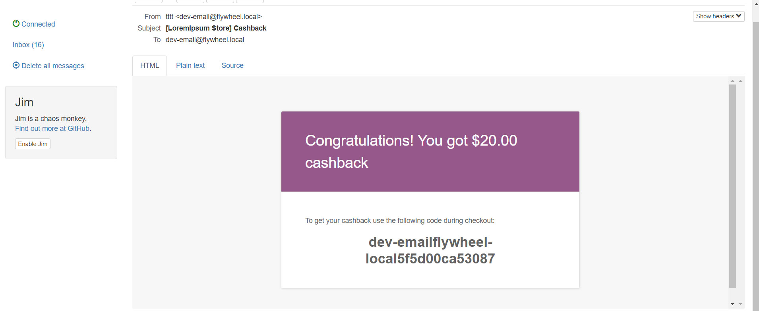

-- End of Document--